Contacts: Sébastien Berche, BROKK, 360-794-1277, sebastien.berche@brokkinc.com
Jeff Keeling, BROKK, 800-621-7856, Jeff.Keeling@brokkinc.com
Katie Grube, IRONCLAD Marketing, 701-373-0062, katie@ironcladmktg.com

Darda Introduces the New MB200 Bolt Cutter
In North America

LAS VEGAS (Jan. 20, 2026) — Darda sets the standard in safety, performance and efficiency with the launch of the MB200 Bolt Cutter. The MB200 is a compact, hydraulic bolt cutter designed to reliably cut high-strength reinforcing steel up to 32 millimeters in diameter using a cold-cutting process — completely without sparks or flames.

The attachment, designed for Brokk demolition robots and other compact carriers, is now available in the United States and Canada through Brokk Inc. and Darda North America. See the new Bolt Cutter attachment paired with a Brokk demolition robot at Booth C4333 in the Central Hall at World of Concrete 2026.

Unlike cut-off grinders, saws or oxygen lances, which expose operators to significant safety risks, the MB200 Bolt Cutter delivers maximum safety even under extreme conditions. Its controlled hydraulic cutting process eliminates fire hazards and flying sparks, making it ideal for use in sensitive environments, confined spaces or areas with elevated safety requirements.

Developed specifically for demolition, dismantling and precise rebar cutting, the MB200 combines outstanding cutting power with exceptional ease of handling. Its compact and ergonomic design allows powerful, clean operation even in tight or hard-to-reach areas, providing professionals with a reliable solution for fast and efficient steel cutting.

With the MB200 Bolt Cutter, Darda delivers a new, high-performance tool for professionals who demand speed, safety and reliability — without compromise.

For more information about MB200 Bolt Cutter in North America, email info@brokkinc.com.

About Darda
Darda is a globally recognized expert in handheld demolition tools and high-performance attachments, including concrete crushers, steel shears, cutters and splitting cylinders. Thanks to their exceptional power-to-weight ratio, Darda products consistently outperform conventional competitors in demanding demolition applications worldwide. Darda North America is a distributor under Brokk Inc. for Darda products in the United States and Canada. For more information in North America: 17321 Tye St. SE Suite B, Monroe, WA 98272; 800-621-7856; info@brokkinc.com; Facebook; Instagram and LinkedIn.

###

IMAGE: Darda_BoltCutter_1.jpg
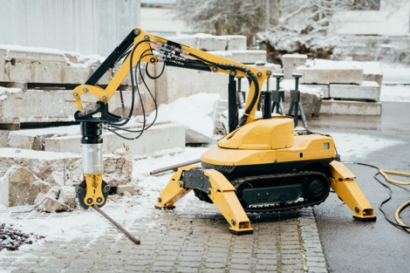
CUTLINE: Darda sets the standard in safety, performance and efficiency with the launch of the MB200 Bolt Cutter.

IMAGE: Darda_BoltCutter_2.jpg
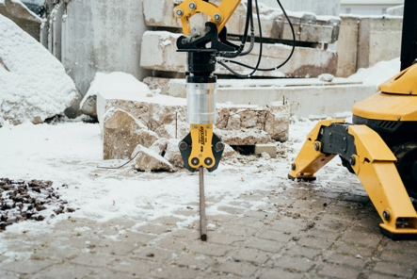
CUTLINE: The MB200 is a compact, hydraulic bolt cutter designed to reliably cut high-strength reinforcing steel up to 32 millimeters in diameter using a cold-cutting process.

IMAGE: Darda_BoltCutter_3.jpg
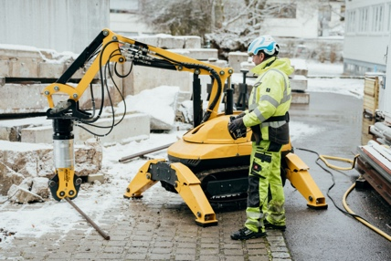
CUTLINE: The MB200’s controlled hydraulic cutting process eliminates fire hazards and flying sparks, making it ideal for use in sensitive environments, confined spaces or areas with elevated safety requirements.

IMAGE: Darda_BoltCutter_4.jpg
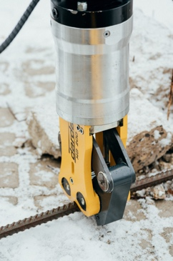
CUTLINE: The MB200’s compact and ergonomic design allows powerful, clean operation even in tight or hard-to-reach areas, providing professionals with a reliable solution for fast and efficient steel cutting.

