Contacts: Jeff Keeling, BROKK, 800-621-7856, jeff.keeling@brokkinc.com
Katie Grube, IRONCLAD Marketing, 701-373-0062, katie@ironcladmktg.com

FOR IMMEDIATE RELEASE

Brokk Revolutionizes Demolition Technology with SmartPower+ Generation

LOUISVILLE, Ky. (Oct. 7, 2025) — Brokk, the world’s leading manufacturer of remote-controlled demolition machines, offers Brokk SmartPower+, a groundbreaking new generation of robots. The SmartPower+ range of machines, including the Brokk 70⁺, 130+, 170⁺, 200⁺, 300⁺ and 500⁺, redefines demolition technology with increased endurance, intelligence and operability.

Brokk Inc. will highlight SmartPower+, along with other utility innovations, at The Utility Expo, Oct. 7-9, 2025, in Louisville, Kentucky, booth N1544.

Unmatched Power & Endurance
Brokk’s SmartPower+ robots provide unmatched endurance by increasing operational uptime with consistent power delivery over time. Expertly engineered with rugged components, Brokk’s SmartPower+ generation is resistant to shock, temperature and vibrations — not to mention that all new robots and control boxes are dust and water protected to an IP65 equivalent — leading to outstanding reliability regardless of the work conditions. Brokk’s SmartPower+ generation also includes a noteworthy 87% reduction in cables and connectors, reducing weak points while facilitating servicing and troubleshooting and increasing the lifespan of the robot.

Operational Excellence
Brokk SmartPower+ revolutionizes the operating experience for both seasoned professionals and new operators alike. More precision, better response times and ease of operation all contribute to operational excellence. Brokk’s SmartPower+ generation redefines the operating experience by introducing a new and improved lightweight control box weighing less than 3kg (or less than 6.5lbs), which contributes to more enjoyable and comfortable work shifts.

The new ergonomically designed control box features tilted joysticks, easier-to-reach features and faster dual charging. Brokk’s SmartPower+ control box includes the innovative Brokk QuickSwitch and intuitive settings for an improved operating experience, making it easier than ever to operate a Brokk robot, and in turn, easier to find and train operators. With Brokk’s new range of SmartPower+ robots and state-of-the-art features, operators can perform the demolition task at hand without shifting their gaze from the machine between commands, and as such, without compromising on performance or safety.

“With nearly five decades of experience, Brokk understands the challenges many industry professionals face in finding skilled operators to get the job done right,” said Martin Krupicka, CEO of Brokk Group. “This is precisely why we are committed to creating solutions for both seasoned professionals and new operators alike, setting a new benchmark in the demolition landscape.”

Intelligence at its Core
This new generation of machines features added intelligence for the operator. Visual status updates through incremental light indicators allow the operator to focus their attention on the demolition work at hand while simultaneously monitoring the status of the machine.

A two-way communication system communicates the status back to the operator in real time, while customized features enhance the operating experience. Brokk’s SmartPower+ generation is much smarter too, alerting the operator about any unwanted power supply or machine statuses, further contributing to an increase in uptime and overall reliability. SmartPower+ is enabled for future over-the-air upgrades to always be at the forefront of the industry.

For more information about Brokk SmartPower+, please visit www.brokk.com.

About Brokk
Brokk has been the world’s leading manufacturer of electric remote-controlled demolition machines and attachments for nearly 50 years. Through continuous innovation in engineering and design, Brokk is able to offer unique solutions to multiple industries worldwide, including construction, demolition, mining and tunneling, cement and metal processing, utility, nuclear and other specialty applications. For more information: Brokk Inc., 17321 TYE Street SE, Suite B, Monroe, WA 98272; 800-621-7856; info@brokkinc.com; www.brokk.com; Facebook; YouTube; LinkedIn and Instagram.

###

IMAGE: Brokk_B70_SP+.jpg
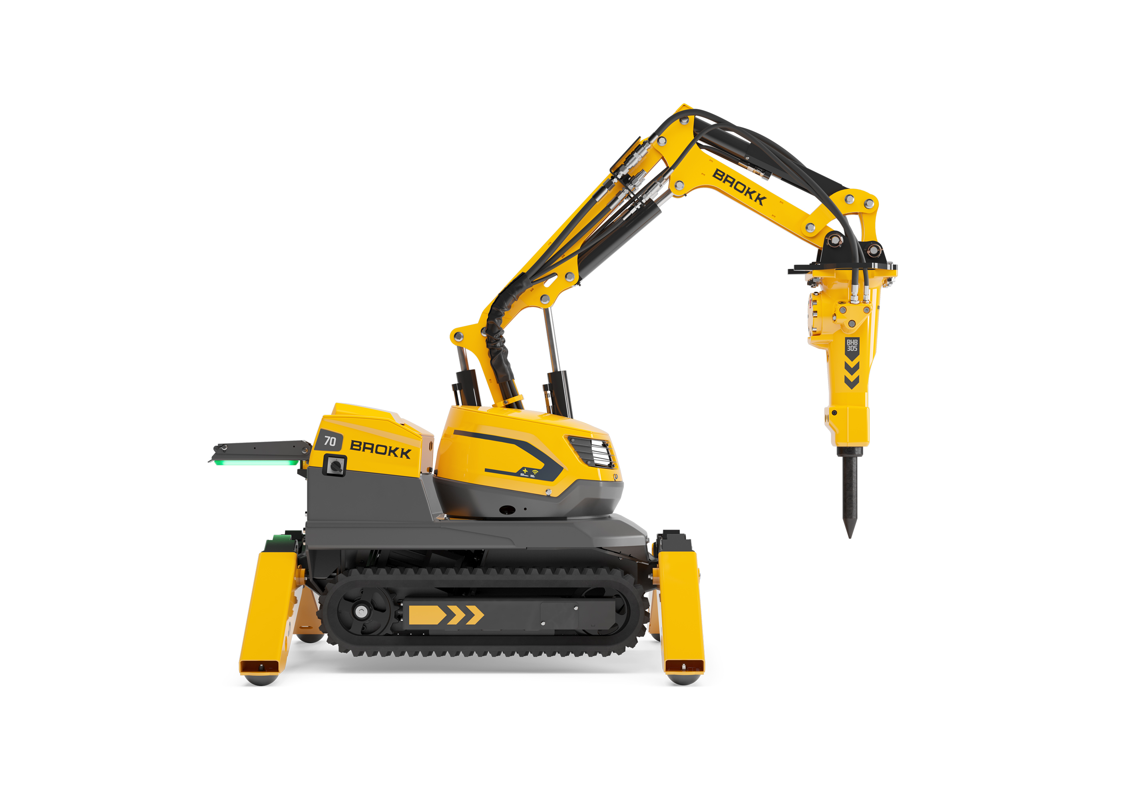
CUTLINE: The Brokk 70+ is an ideal solution for breaking utility lines out of concrete, particularly in tight spaces.

IMAGE: Brokk_ControlUnit.jpg
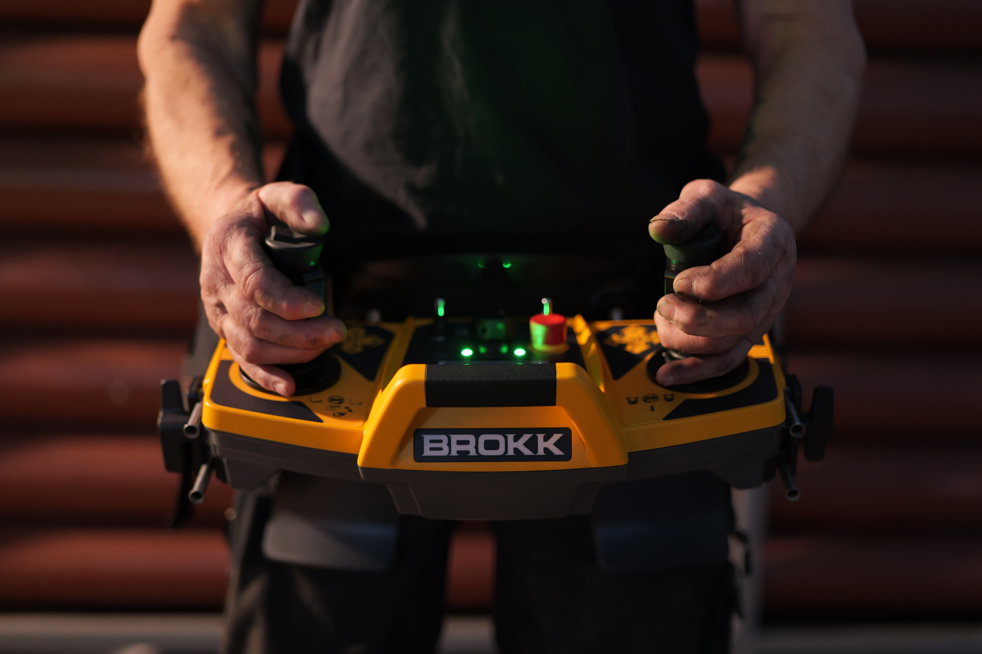
CUTLINE: Brokk’s SmartPower+ control box includes the innovative Brokk QuickSwitch and intuitive settings for an improved operating experience, making it easier than ever to operate a Brokk robot, and in turn, easier to find and train operators.

Suggested Tags: Brokk, Brokk robot, compact equipment, utility, The Utility Expo

Suggested Social Media Posts: @BrokkUSA to highlight their SmartPower+ robots at The Utility Expo 2025. [link and photo]

Facebook Handle: @BrokkUSA
LinkedIn Handle: Brokk Inc.
YouTube Handle: @BrokkIncUSA
Instagram Handle: @BrokkUSA

