Contacts: Jeff Keeling, BROKK, 800-621-7856, Jeff.Keeling@brokkinc.com
Katie Grube, IRONCLAD Marketing, 701-373-0062, katie@ironcladmktg.com

FOR IMMEDIATE RELEASE

Brokk Inc. named dealer for FIRSTGREEN Industries

LOUISVILLE, Ky. (Oct. 7, 2025) — Brokk Inc., the North American distributor for Brokk demolition robots and Aquajet Hydrodemolition equipment, is now a dealer for FIRSTGREEN Industries’ electric, zero-emission, low-noise loaders. The FIRSTGREEN products complement Brokk’s product line, whether users are seeking an electric solution for loading or want to move closer to a fully electric, remote-controlled jobsite by pairing Brokk demolition robots with FIRSTGREEN loaders.

“We are very excited to add FIRSTGREEN’s innovative technologies to our offerings in North America,” said Jeff Keeling, vice president for sales and marketing at Brokk Inc. “Being electric and remote-controlled fits perfectly with our commitment to seeing operators safe in hazardous environments.”

Brokk Inc. carries the full line of FIRSTGREEN products and plans to showcase the MiniZ 400 at The Utility Expo, Oct. 7-9, 2025, in Louisville, Kentucky, booth N1544. The MiniZ 400 is a compact, remote-controlled tracked loader. Small enough to fit through a standard doorway, the MiniZ 400 is ideal for limited space applications.

Brokk Inc. also offers the following FIRSTGREEN products:

- The Rockeat Line — Low-profile, cabinless, electric skid steers with a loading capacity up to 2,646 lbs. (1,200 kg).

- The Elise Line — Compact, but large capacity machines that are battery operated and feature a cab.

- The CBL Line — An Elise built cabinless for a lower profile and ideal for hazardous environments.

All FIRSTGREEN loaders feature lithium or lead-acid batteries that can last up to 6 hours of continuous use. Batteries can also be “hot swapped” to continue working with minimal downtime.

Like Brokk, FIRSTGREEN offers a variety of attachments to ensure its machines are highly versatile workhorses that quickly generate a return on investment. Attachment options include a 4-in-1 bucket, concrete mixer, pallet forks, auger and more.

"We are thrilled to welcome Brokk Inc. as our newest partner with FIRSTGREEN Industries,” said Marcus Suess, chief operating officer for FIRSTGREEN Industries USA. “Brokk’s extensive experience and leadership in the industry align perfectly with our mission to drive innovation, safety and sustainability. Together, we look forward to delivering cutting-edge solutions that enhance efficiency and drive exceptional results."

About Brokk
Brokk has been the world’s leading manufacturer of electric remote-controlled demolition machines and attachments for nearly 50 years. Through continuous innovation in engineering and design, Brokk is able to offer unique solutions to multiple industries worldwide, including construction, demolition, mining and tunneling, cement and metal processing, utility, nuclear and other specialty applications. For more information: Brokk Inc., 17321 TYE Street SE, Suite B, Monroe, WA 98272; 800-621-7856; info@brokkinc.com; www.brokk.com; Facebook; YouTube; LinkedIn and Instagram.

About FIRSTGREEN Industries
FIRSTGREEN Industries builds all-electric, zero-emission and low-noise loaders. Designed by a dedicated development team, machines reflect its commitment to sustainability and environmental respect. Based in the Czech Republic, the company is focused on efficiency, safety and environmental sustainability. In 2023, FIRSTGREEN Industries expanded with a new branch in North Carolina, marking a significant milestone for American operations. This branch ensures timely delivery of machines and maintains an extensive spare parts inventory for U.S. customers. For more information: https://first.green/en.

###

IMAGE: Brokk_FIRSTGREEN_MiniZ_1.jpg
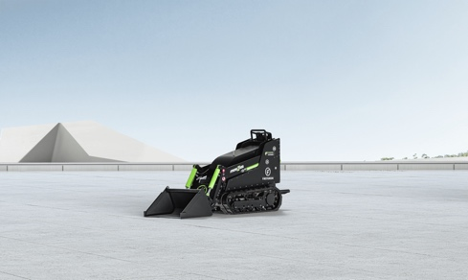
CUTLINE: FIRSTGREEN’s MiniZ 400 is compact enough to travel through a standard doorway, making it the perfect complement to a Brokk demolition robot.

IMAGE: Brokk_FIRSTGREEN_MiniZ_2.jpg
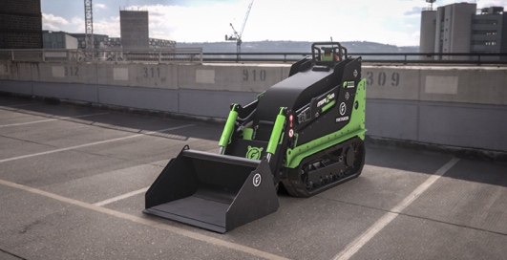
CUTLINE: Brokk Inc. plans to showcase the MiniZ 400 at The Utility Expo, Oct. 7-9, 2025, in Louisville, Kentucky, booth N1544.

Suggested Tags: Brokk, FIRSTGREEN Industries, electric equipment, remote-controlled equipment, The Utility Expo

Suggested Social Media Post: @Brokk Inc. offers FIRSTGREEN Industries’ MiniZ 400, ideal for limited space utility applications. (link and photo).

Facebook Handle: @BrokkUSA
LinkedIn Handle: Brokk Inc.
Instagram: @brokkusa
YouTube Handle: @BrokkIncUSA

