Contacts: Jeff Keeling, BROKK, 800-621-7856, Jeff.Keeling@brokkinc.com
Katie Grube, IRONCLAD Marketing, 701-373-0062, katie@ironcladmktg.com

FOR IMMEDIATE RELEASE

Brokk Inc. named dealer for Ecovolve electric dumpers

LOUISVILLE, Ky. (Oct. 7, 2025) — Brokk Inc., the North American distributor for Brokk demolition robots and Aquajet Hydrodemolition equipment, is now a dealer for Ecovolve electric, high-tip dumpers. With low noise and a charge that lasts eight hours, a compact Ecovolve electric dumper is a perfect partner for debris clean-up during demolition with a Brokk robot. The electric dumpers are also an ideal solution for any type of debris removal where the user is interested in fuel and maintenance savings or requires low-noise, emission-free equipment.

“Like Brokk, Ecovolve products are electric and compact — perfectly suited for interior demolition or any situation where fumes and access are a concern,” said Jeff Keeling, vice president of sales and marketing at Brokk Inc. “Adding this innovative equipment to our lineup provides customers the possibility of a fully electric demolition project, including clean-up.”

Brokk Inc. carries the full line of Ecovolve’s electric dumpers and will highlight the entire dumper line at The Utility Expo, Oct. 7-9, 2025, in Louisville, Kentucky, booth N1544.

Brokk Inc. offers the following Ecovolve dumpers:

- The ED800 is Ecovolve’s most compact electric dumper and is small enough to travel through a 31.5-inch doorway, making it ideal for limited space utility applications. It improves productivity with its 1,763-pound load capacity and tipping height of up to 58 inches.
- The ED1000 is a popular workhorse due to its versatile size and capacity. Load up to 2,200 pounds in the skip and tip up to 58 inches.

- The ED1500 is for large loads, with a load capacity up to 3,300 pounds and high tipping up to 63 inches.

Ecovolve electric dumpers feature batteries that offer eight hours of continuous work. Running at 65 decibels, the noise level is comparable to normal conversation. The ED line also features a 63-inch turn radius, allowing the dumpers to work in a small footprint. Options include a remote control for even greater safety and the Ecochute attachment for pouring concrete.

The electric dumpers are also low maintenance compared to diesel equipment. Maintenance includes monthly greasing and a full charge/discharge of the power pack. They also feature maintenance-free tires, including a no-mark option.

Visit https://www.brokk.com/us/ for more information.

About Brokk
Brokk has been the world’s leading manufacturer of electric remote-controlled demolition machines and attachments for nearly 50 years. Through continuous innovation in engineering and design, Brokk is able to offer unique solutions to multiple industries worldwide, including construction, demolition, mining and tunneling, cement and metal processing, utility, nuclear and other specialty applications. For more information: Brokk Inc., 17321 TYE Street SE, Suite B, Monroe, WA 98272; 800-621-7856; info@brokkinc.com; www.brokk.com; Facebook; YouTube; LinkedIn and Instagram.

About Ecovolve
Established in 2010, Ecovolve is an electric equipment manufacturer based in Ireland.

###

IMAGE: Ecovolve_ED800.jpg
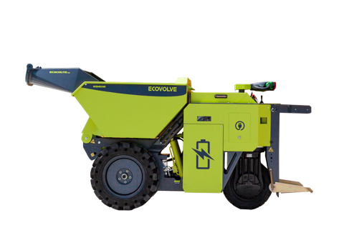
CUTLINE: The Ecovolve electric dumpers are an ideal solution for any type of debris removal where the user is interested in fuel and maintenance savings or requires low-noise, emission-free equipment.

Suggested Tags: Brokk, Ecovolve, electric equipment, electric dumpers, high-tip dumpers, Utility Expo

Suggested Social Media Post: @Brokk Inc. offers the Ecovolve ED 800 electric dumpers for utility appliations. (link and photo).

Facebook Handle: @BrokkUSA
LinkedIn Handle: Brokk Inc.
Instagram: @brokkusa
YouTube Handle: @BrokkIncUSA

