Contacts: Jeff Keeling, BROKK, 800-621-7856, jeff.keeling@brokkinc.com
Katie Grube, IRONCLAD Marketing, 701-373-0062, katie@ironcladmktg.com

FOR IMMEDIATE RELEASE

Brokk Highlights Remote-Controlled Vacuum Excavation Solution at The Utility Expo

LOUISVILLE, Ky. (Oct. 7, 2025) — Brokk, the world’s leading manufacturer of remote-controlled demolition machines, will be highlighting the Brokk Vacuum Excavator at The Utility Expo, Oct. 7-9, 2025, in Louisville, Kentucky, booth N1544. A compact, remote-controlled Brokk robot combined with a vacuum excavation kit is an ideal solution for excavation sites, such as those in residential areas, that are difficult or impossible to reach with a vacuum excavation truck.

The Brokk Vacuum Excavator includes a bracket mounted on the rear of the machine and on the three-part arm to secure the hose and transport it from the vacuum excavation truck to the excavation site. A specially designed plate attaches to the end of the Brokk’s arm and includes an opening to hold and stabilize the hose’s nozzle. Thanks to the quick hitch, the plate can be rapidly removed and switched with a variety of attachments, including breakers, buckets and drum cutters.

The most common Brokk Vacuum Excavator unit is the Brokk 120DII. At 31 inches (787.4 millimeters) wide, 80 inches (2,023 millimeters) long and 49 inches (1,244.6 millimeters) high, the 2,700-pound (1,225-kilogram) Brokk 120DII is the smallest diesel-powered machine in Brokk’s lineup. Brokk’s other diesel-powered robots include the much larger Brokk 520D and Brokk 900. Brokk also offers a range of electric models that can be equipped with the vacuum excavation kit.

To maximize service life, the Brokk 120DII and all other models are compatible with Brokk Connect 2.0, an online platform that provides access to real-time information about the status of the robot, operational data, service needs and more.

Visit https://www.brokk.com/us/ to learn more about Brokk electric and diesel models and the attachments available for those models.

About Brokk
Brokk has been the world’s leading manufacturer of electric remote-controlled demolition machines and attachments for nearly 50 years. Through continuous innovation in engineering and design, Brokk is able to offer unique solutions to multiple industries worldwide, including construction, demolition, mining and tunneling, cement and processing, utility, nuclear and other specialty applications. They also offer a full range of electric equipment, including the Brokk 70⁺, 130+, 170⁺, 200⁺, 300⁺ and 500⁺. For more information: Brokk Inc., 17321 TYE Street SE, Suite B, Monroe, WA 98272; 800-621-7856; info@brokkinc.com; www.brokk.com; Facebook; YouTube; LinkedIn and Instagram.

###

IMAGE: Brokk_Vacuum_Excavator_1.jpg
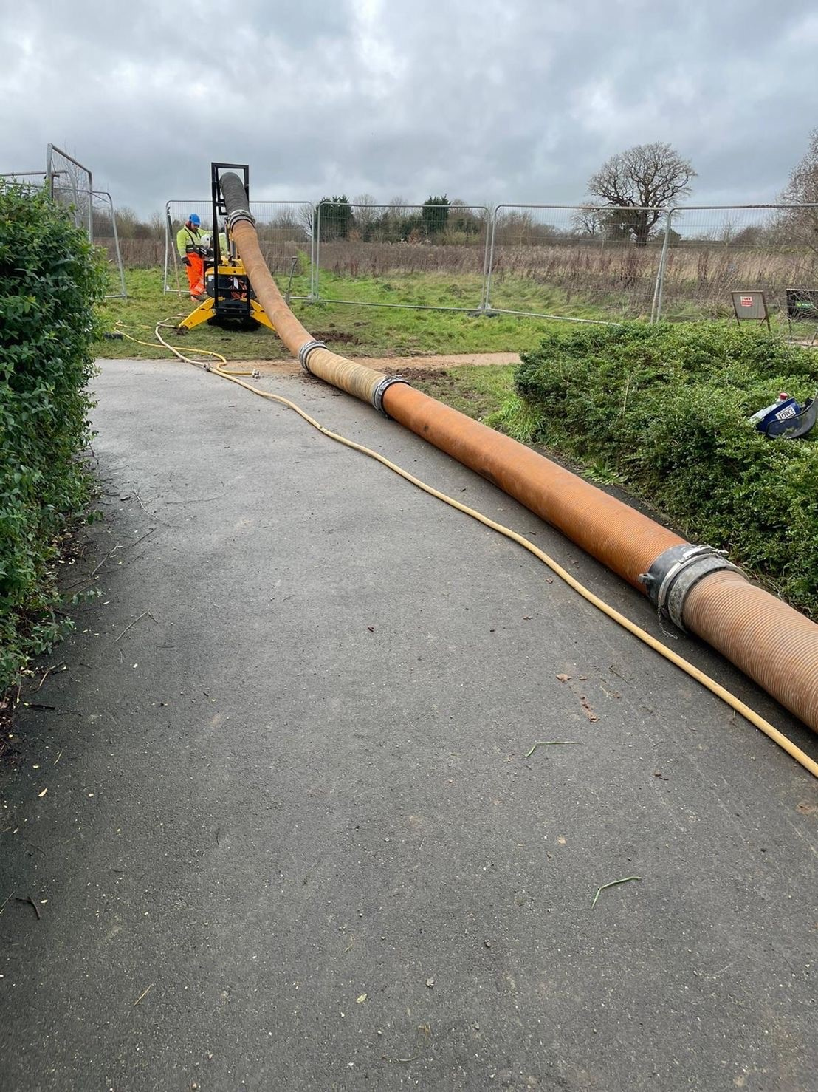
CUTLINE: Brokk will highlight the Brokk Vacuum Excavator, along with other equipment innovations, at The Utility Expo from Oct. 7-9, in Louisville, Kentucky. Stop by booth N1544 for more information.

IMAGE: Brokk_Vacuum_Excavor_2.jpg
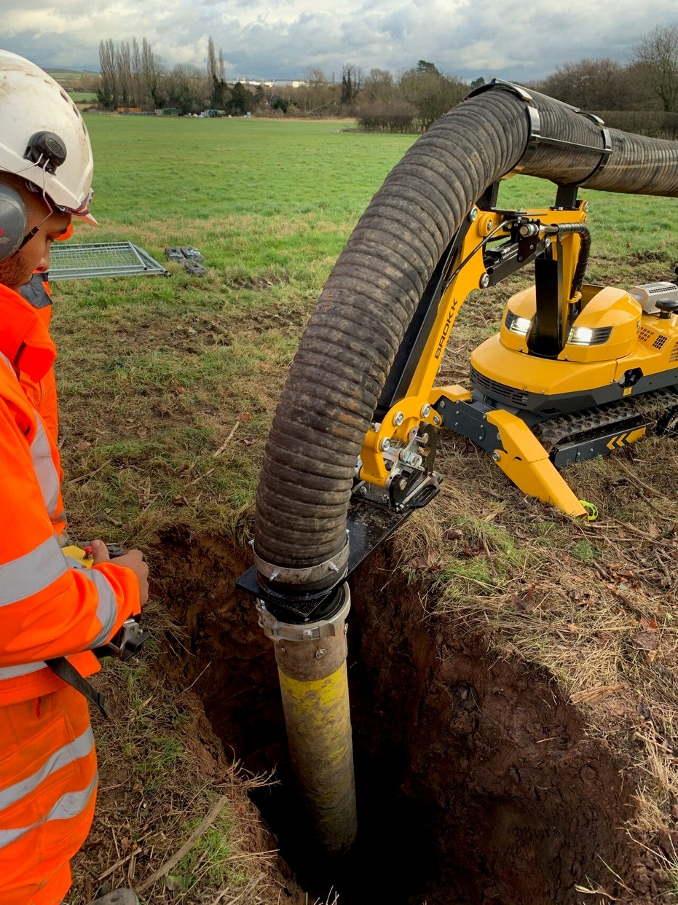
CUTLINE: No need for the crew to handle the hose when there is zero truck access. The compact, wireless Brokk 120DII equipped for vacuum excavation transports the hose from truck to site.

IMAGE: Brokk_Vacuum_Excavator_3.jpg
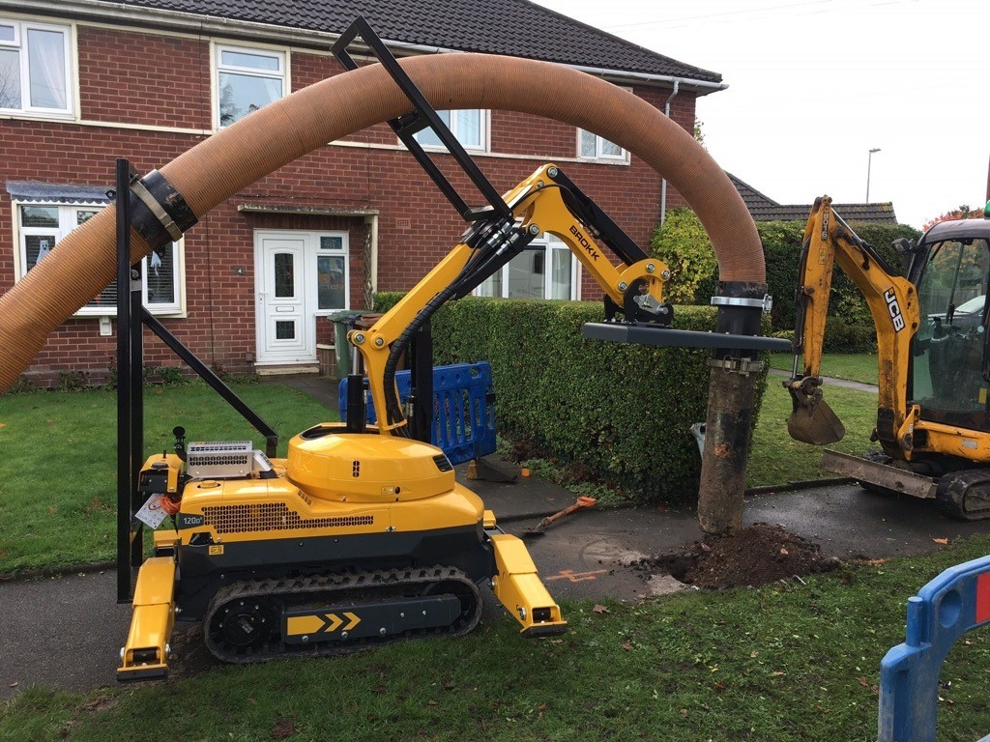
CUTLINE: Brokk’s vacuum excavation kit includes a bracket mounted on the rear of the machine and on the three-part arm to secure the hose and transport it from the vacuum excavation truck to the excavation site.

Suggested Tags: Brokk, Brokk robot, diesel, remote-controlled demolition, compact equipment, vacuum excavation, utility, The Utility Expo

Suggested Social Media Posts: @BrokkUSA highlights the Brokk Vacuum Excavator at The Utility Expo 2025. {Link & Photo}

Facebook Handle: @BrokkUSA
LinkedIn Handle: Brokk Inc.
YouTube Handle: @BrokkIncUSA
Instagram Handle: @BrokkUSA

